***Calendar***

**Baptisms.** *. . . . . . . . . . . . . . . . . . . . . . . . . . . . . . . . . . . . . . . . . . . . . . . . . . . .* 3rd Sunday

*(To arrange a Baptism, please speak to Annette Strawder or call the church office)*

**Bible Study Classes:**

Adult Sunday School . . . . . . . . . . . . . . . .. . . . . . . . . . . . . . . . . . . *. .*Sunday, 9:30 a.m.

Sunday School *(classes for youth)* . . . . . . . . . . . . . . . . . . . .. . . . . . .Sunday, 9:45 a.m.

*(To sign up please add name to calendar in the first floor kitchen)*

**Committee Meetings:**

Board of Trustees . . . . . . . . . . . . . . . . . . . . . . . . . . . . . . . . . .*. .. . . . . .*.... .3rd Saturday

Membership Committee…………………………………………………………………4th Sunday

Men’s Christian Fellowship………………………………………………………….. .. 1st Sunday

Music Committee . . . . . . . . . . . . . . . . . . . . . . . . . . . . . ... . . . . . . .. . . . . ..3rd Sunday

Standing Committee . . . . . . . . . . . . . . . . . . . . . . . . .. . . . . . . . . . . . . . .. . 2nd Sunday

**Communion** . . . . . . . . . . . . . . . . . . . . . . . . . . . . . .1st Sunday and Maundy Thursday

**Reception of New Members** . . . . . . . . . . . . . . . . . . . . . . . . . . . . . . . . . . .1st Sunday

_____________________________________________________________________

Alcoholics Anonymous/Al-Anon . . . . . . . . Wednesday, 7:00 p.m.

Narcotics Anonymous . . . . . . . . . . . . . . . . . Weekdays 10:00 a.m. and 12:00 noon

_____________________________________________________________________

**Contact Information**

**Weekday Office Hours for the Church:**

**Tuesdays, Wednesdays, and Fridays 11:00am – 5:30pm**

**Office (718) 282 - 5353 Fax (718) 940 - 0988**

**Rev. Forde has office hours on Wednesdays -10:00 – 4:00pm**

**(929) 519 - 3242**

**Flatbush-Tompkins**

**Congregational Church**

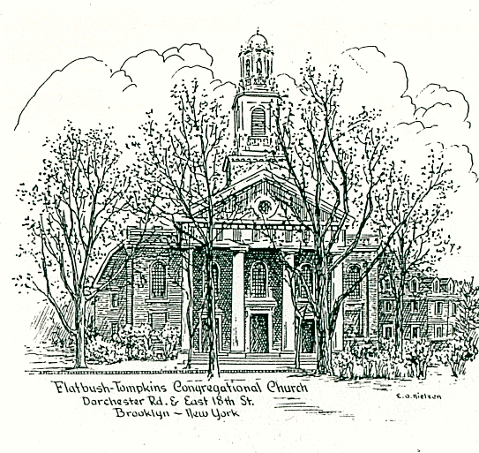

424 East Nineteenth Street, Brooklyn, New York 11226

Tel. 718-282-5353 / Fax 718-940-0988

**Reverend Doreen Forde**

Interim Minister

The mission of this church is to provide a place to worship and learn the

will of God; to share in Christian fellowship showing encouragement and

love to each other, gaining spiritual strength for our personal needs

and, as disciples of Christ, to communicate our love to all people

by deeds and actions.

____________________________________________________________________ ***Sunday August 24, 2025***

***at 11:00 a.m. in the morning***

*________________________________________________________________________________________________________________________________________*

*Member*

NATIONAL ASSOCIATION of CONGREGATIONAL CHRISTIAN CHURCHES

**FLATBUSH-TOMPKINS CONGREGATIONAL CHURCH**

**Rev. Doreen Forde, *Interim Minister***

***Liturgist: Sandra Plummer-Cambridge***

**Sunday, August 24th, 2025 at 11:00am**

**Prelude** God’s Blessings*R. Kaufman*

**\*Opening Hymn** #48 Love Divine, All Loves Excelling *Wesley/Zundel*

**\*Call to Worship**

With profound happiness, we welcome one another.

How good it is to approach the courts of our God!

**Happy are those who live in God’s house!**

**Singing our praise to God fills us with joy.**

Here we welcome both friend and stranger.

All peoples of the earth are God’s children.  
 **We greet one another by name in Jesus’ name.  
 Together we extol the name of our God.**

Open your hearts to receive new strength.

Open your lives to renewed understandings.

**Surely God will equip us to face our world.**

**We will be ambassadors for God wherever we go.**

**\*Introit** This Is the Day the Lord Hath Made *I. Watts*

**\*Invocation and Lord’s Prayer** *(debts……debtors*)

**\*Responsive Reading**

**\* Psalter 624 Psalm 42**

**\*Gloria Patri** *Avery & Marsh*

**Welcome and Announcements**

**Pastoral Prayer**

**Prayer Response** Lord Listen to Your Children Praying*Medema*

**Offering**

**Anthem**  A Simple Song *Schwartz/Bernstein*

KyleCarson

**\*Doxology** *Avery & Marsh*

**\*Prayer of Dedication**

**Scripture Reading**

**New Testament Lesson** (pew Bible p.1062 & 1063)Galatians 5:19-23

“ “ “ (pew Bible p. 1084) 2 Timothy 1:7

**\*Hymn of Preparation** #268 **I Need Thee Every Hour** *Lowery*

**Sermon The Spirit of Self-Control**

**Invitation to Christ**

**Hymns of Invitation**

**#**332 And Can It Be that I Should Gain

#413 Sweet Hour of Prayer

#426 God Leads Us Along

**\*Closing Hymn** #452 Stand Up, Stand Up for Jesus *Duffield/Webb*

**\*Benediction**

**\*Choral Response Go In Peace** *White*

Go in peace and the peace of God be with you this day

Go in peace and the peace of God be with you alway

Celebrate and share the joy! Celebrate new life!

Go in peace and the peace of God be with you alway

**Postlude** He Protects You *R. Kaufman* Sevil Macmot

\**congregation standing (Please remain seated until after the Postlude is finished.*

*\* (Please remain seated until after the Postlude is finished.***)**

**Music Ministry**

Kyle Carson , Baritone

Rachel Kaufman, Pianist

**Thank you to the Tech Ministry for their work.**

**The greeters this morning are Annette Strawder & John Jackson.**

**Church Notes**

We welcome you to our service of worship this morning. We are so

pleased, that you have come to fellowship with us today. We encourage

you to greet each other and join us for fellowship after service.

**Notice to Church Members:**

In place of the weekly income postings previously included in the Sunday Bulletin, the Board of Trustees will begin providing a summary of the Church’s monthly income and expenses to all members, starting the second Sunday in August.

This information will be distributed via email each month and printed copies will be made available upon request.

FTCC Board of Trustees

*Behind all words and gestures, behind all thoughts and feelings, there is*

*an inner center of prayer where we can meet and help one another in*

*the presence of God. Let us remember in prayer –*

Lion Alkebulan, requested by Davida Davis Ella Brandon*

J.W. Eady, uncle of Sylvia White Mary and Floyd Mitchell*\**

Wilbert Mills* Tara Charles & Family Anthony Davis*\**

Janet Baugh, a friend of the Matthew Family Joycelyn McCalla*

Thelma Borden Patsy Gordon,*for healing

James Brannon, nephew of Janice Thomas Avenal Haynes*

Linell Adrienne Booker*&Family

Collins Jacobs, father of Desiree Jacobs Munnelly Rev. Joe N. Brown

Audrey Mills, wife of Wilbert Mills Cathleen Reid*

Demetrice Mills, brother of Wilbert Mills Florence Robinson*

Edris Sewell,* for healing Enid Williams*

Laura Harris* and family Joan Regis*

Nancy Van Raalte, aunt of Rachel Kaufman Nora White

Jean Jackson, sister of John Jackson Kaylani Best Cree Roderick Applewhaite

Claudia Rollins-Carrington Cynthia Hall*

Iotha Floyd* Colville Young

William Stevens, brother of Elisabeth Stevens Richard Franza

Lillie Clachar residing at Signature Senior Living Home* Karen HinksonBarbra Quick Milton Quick

Bishop Carl Bellamy, Cousin of Wilbert Mills Phillip Thomas

Luciano Granato

Anderson Haynes- Brother of Annette Strawder and Sonia Clarke Joshua Bagwell

**Happy Birthday** to our August birthday celebrants. 8/1Katherine Petrone ,

8/2 Phyllis Caldwell, 8/3 Jasmine Bryant, 8/11 Donatello Petrone, 8/8 Alexis White Basso,

8/29 Zora Denise Flowers-Ryan.

**Pennies for the Building Fund:** You are invited to deposit your pennies

into the large bottle on the table at the East 19th Street entrance.

**For all meeting requests on Zoom, please notify the IT Committee by Email**

**at** [**IT@flatbushtompkins.org**](mailto:IT@flatbushtompkins.org)**.**

**Save the Date:** November 1st - Prayer Breakfast 9a.m.