***Calendar***

**Baptisms.** *. . . . . . . . . . . . . . . . . . . . . . . . . . . . . . . . . . . . . . . . . . . . . . . . . . . .* 3rd Sunday

*(To arrange a Baptism, please speak to Annette Strawder or call the church office)*

**Bible Study Classes:**

Adult Sunday School . . . . . . . . . . . . . . . .. . . . . . . . . . . . . . . . . . . *. .*Sundays, 9:30 a.m.

Sunday School *(classes for youth)* . . . . . . . . . . . . . . . . . . . .. . . . . . .Sundays, 9:45 a.m.

*(To sign up please add name to calendar in the first floor kitchen)*

**Committee Meetings:**

Board of Trustees . . . . . . . . . . . . . . . . . . . . . . . . . . . . . . . . . .*. .. . . . . ..* . . .3rd Saturday

Membership Committee……………………………………………………….4th Sunday

Men’s Christian Fellowship……………………………………………….. 1st Sunday

Music Committee . . . . . . . . . . . . . . . . . . . . . . . . . . . . . ... . . . . . . .. . . . . .. ..3rd Sunday

Standing Committee . . . . . . . . . . . . . . . . . . . . . . . . .. . . . . . . . . . . . . . . . . . . 2nd Sunday

Youth Meeting *(for high school seniors)* . . . . . . . . . . . . . . . . . . . . . . . . . Fridays, 7 p.m.

**Communion** . . . . . . . . . . . . . . . . . . . . . . . . . . . . . . . .1st Sunday and Maundy Thursday

**Reception of New Members** . . . . . . . . . . . . . . . . . . . . . . . . . . . . . . . . . . . . .1st Sunday

_____________________________________________________________________

Alcoholics Anonymous/Al-Anon . . . . . . . . . Tuesday and Wednesday, 7:00 p.m.

Narcotics Anonymous . . . . . . . . . . . . . . . . . Weekdays 10:00 a.m. and 12:00 noon

_____________________________________________________________________

**Contact Information**

**Weekday Office Hours for the church:**

**Tuesdays, Wednesdays, and Fridays 11:00am – 5:30pm**

**Office (718) 282 - 5353 Fax (718) 940 - 0988**

**Rev. Forde has office hours on Wednesdays -10:00 – 4:00pm**

**(929) 519 - 3242**

Flatbush-Tompkins

Congregational Church

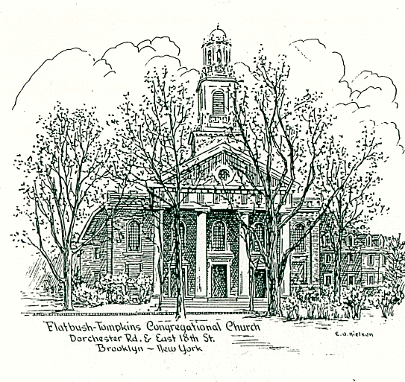

424 East Nineteenth Street, Brooklyn, New York 11226

Tel. 718-282-5353 / Fax 718-940-0988

**Reverend Doreen Forde**

Interim Minister

The mission of this church is to provide a place to worship and learn the

will of God; to share in Christian fellowship showing encouragement and

love to each other, gaining spiritual strength for our personal needs

and, as disciples of Christ, to communicate our love to all people

by deeds and actions.

____________________________________________________________________ ***Sunday July 27, 2025***

***at 11:00 a.m. in the morning***

*_________________________________________________________________________________________________________________________________________________*

*Member*

NATIONAL ASSOCIATION of CONGREGATIONAL CHRISTIAN CHURCHES

**FLATBUSH-TOMPKINS CONGREGATIONAL CHURCH**

**Rev. Doreen Forde, *Interim Minister***

***Liturgist: Sonia Clarke***

**Sunday, July 27th, 2025 at 11:00am**

**Prelude** Reflection*R. Kaufman*

**\*Opening Hymn** #491 In Christ We Are One Body *Gardiner*

**\*Call to Worship**

This is the hour to bend our knee before God.

This is the time to offer our best to our Creator.  
 **We gather before God, who sees all our deeds.**

**We open our hearts to One who knows all our thoughts.**Fools say in their hearts, ”There is no God.”

We come together proclaiming, “God is with us!”  
 **We come to be strengthened in our inner being.**

**We seek to pattern our actions after Christ Jesus.**God’s presence evokes our joyous worship.

TheHoly Spirit empowers our Service.  
 **To God be highest glory in the church.  
 To God be endless adoration in the world.**

Amen. **Amen.**

**\*Introit** Bind Us Together *Gillman*

**\*Invocation and Lord’s Prayer** *(debts……debtors*)

**\*Responsive Reading**

**\* Psalter 611 Psalm 30**

**\*Gloria Patri** *Avery & Marsh*

**Welcome and Announcements**

**Pastoral Prayer**

**Prayer Response** Lead Me Lord *Wesley*

**Offering**

**Anthem**  Center of My Joy *Smallwoood/Gaither*

Women’s Ministry

**\*Doxology** *Avery & Marsh*

**\*Prayer of Dedication**

**Scripture Reading**

**New Testament Lesson** (pew Bible p.1119**)** Revelation 3: 7-13

**\*Hymn of Preparation *(****Insert)* **Hold to God’s Unchanging Hand**

**Sermon Hold On**

**Invitation to Christ**

**Hymn of Invitation**

#546 Revive Us Again

**#**332 And Can It Be that I Should Gain

#75 Ye Servants of God, Your Master Proclaim

**\*Closing Hymn** *#485* Glorious Things of Thee Are Spoken *Newton/Haydn*

**\*Benediction**

**\*Choral Response Go In Peace** White

Go in peace and the peace of God be with you this day

Go in peace and the peace of God be with you alway

Celebrate and share the joy! Celebrate new life!

Go in peace and the peace of God be with you alway

**Postlude** Celebrate Him *R. Kaufman* Sevil Macmot

\**congregation standing (Please remain seated until after the Postlude is finished.*

*(Please remain seated until after the Postlude is finished.***)**

**Music Ministry**

Women’s Ministry

Rachel Kaufman, Pianist

**Thank you to the Tech Ministry for their work.**

**The greeters this morning are Orrin Applewhaite & Janice Thomas.**

**Church Notes**

We welcome you to our service of worship this morning. We are so

pleased that you have come to fellowship with us today. We encourage

you to greet each other and join us for fellowship after service. The children will have their lemonade stand after service.

**There will be a Prayer Service** on August 2nd in the Parlor at 10a.m., as we prepare as a church to make additional decisions regarding the guidance and charge of this campus.

*Behind all words and gestures, behind all thoughts and feelings, there is*

*an inner center of prayer where we can meet and help one another in*

*the presence of God. Let us remember in prayer –*

Lion Alkebulan, requested by Davida Davis Ella Brandon*

J.W. Eady, uncle of Sylvia White Mary and Floyd Mitchell*\**

Wilbert Mills* Tara Charles & Family Anthony Davis*\**

Janet Baugh, a friend of the Matthew Family Joycelyn McCalla*

Thelma Borden Patsy Gordon,*for healing

James Brannon, nephew of Janice Thomas Avenal Haynes*

Linell Adrienne Booker*

Collins Jacobs, father of Desiree Jacobs Munnelly Rev. Joe N. Brown

Audrey Mills, wife of Wilbert Mills Cathleen Reid*

Demetrice Mills, brother of Wilbert Mills Florence Robinson*

Edris Sewell,* for healing Enid Williams*

Laura Harris* and family Joan Regis*

Nancy Van Raalte, aunt of Rachel Kaufman Nora White

Jean Jackson, sister of John Jackson Kaylani Best Cree Roderick Applewhaite

Claudia Rollins-Carrington Cynthia Hall*

Iotha Floyd* Colville Young

William Stevens, brother of Elisabeth Stevens Richard Franza

Lillie Clachar residing at Signature Senior Living Home* Karen HinksonBarbra Quick at Diitmas Rehab Center.*

Bishop Carl Bellamy, Cousin of Wilbert Mills

Luciano Granato Rachel Kaufman

Anderson Haynes- Brother of Annette Strawder and Sonia Clarke Joshua Bagwell

**Happy Birthday** to our July birthday celebrants.

Gwenyth Als- July 4th, Brandon Roberts Blake -July 12th

Sharon Roberts Blake -July 14th, Marshall Bryant -July 31st,

Heather Thompson-July 31st

**Happy 102nd Heavenly Birthday to Avenal Haynes.**

**Pennies for the Building Fund:** You are invited to deposit your pennies

into the large bottle on the table at the East 19th Street entrance.

**For all meeting requests on Zoom, please notify the IT Committee by Email**

**at IT@flatbushtompkins.org.**

**Save the Date:** November 1st - Prayer Breakfast 9a.m.