***Calendar***

**Baptisms.** *. . . . . . . . . . . . . . . . . . . . . . . . . . . . . . . . . . . . . . . . . . . . . . . . . . . .* 3rd Sunday

*(To arrange a Baptism, please speak to Annette Strawder or call the church office)*

**Bible Study Classes:**

Adult Sunday School . . . . . . . . . . . . . . . .. . . . . . . . . . . . . . . . . . . *. .*Sundays, 9:30 a.m.

Sunday School *(classes for youth)* . . . . . . . . . . . . . . . . . . . .. . . . . . .Sundays, 9:45 a.m.

*(To sign up please add name to calendar in the first floor kitchen)*

**Committee Meetings:**

Board of Trustees . . . . . . . . . . . . . . . . . . . . . . . . . . . . . . . . . .*. .. . . . . ..* . . .3rd Saturday

Membership Committee……………………………………………………….4th Sunday

Men’s Christian Fellowship……………………………………………….. 1st Sunday

Music Committee . . . . . . . . . . . . . . . . . . . . . . . . . . . . . ... . . . . . . .. . . . . .. ..3rd Sunday

Standing Committee . . . . . . . . . . . . . . . . . . . . . . . . .. . . . . . . . . . . . . . . . . . . 2nd Sunday

Youth Meeting *(for high school seniors)* . . . . . . . . . . . . . . . . . . . . . . . . . Fridays, 7 p.m.

**Communion** . . . . . . . . . . . . . . . . . . . . . . . . . . . . . . . .1st Sunday and Maundy Thursday

**Reception of New Members** . . . . . . . . . . . . . . . . . . . . . . . . . . . . . . . . . . . . .1st Sunday

_____________________________________________________________________

Alcoholics Anonymous/Al-Anon . . . . . . . . . Tuesday and Wednesday, 7:00 p.m.

Narcotics Anonymous . . . . . . . . . . . . . . . . . Weekdays 10:00 a.m. and 12:00 noon

_____________________________________________________________________

**Contact Information**

**Weekday Office Hours for the church:**

**Tuesdays, Wednesdays, and Fridays 11:00am – 5:30pm**

**Office (718) 282 - 5353 Fax (718) 940 - 0988**

**Rev. Forde has office hours on Wednesdays -10:00 – 4:00pm**

**(929) 519 - 3242**

Flatbush-Tompkins

Congregational Church

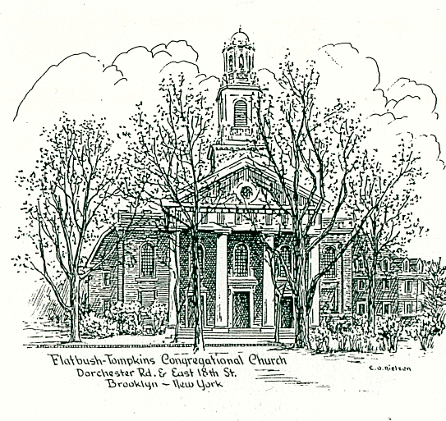

424 East Nineteenth Street, Brooklyn, New York 11226

Tel. 718-282-5353 / Fax 718-940-0988

**Reverend Doreen Forde**

Interim Minister

The mission of this church is to provide a place to worship and learn the

will of God; to share in Christian fellowship showing encouragement and

love to each other, gaining spiritual strength for our personal needs

and, as disciples of Christ, to communicate our love to all people

by deeds and actions.

____________________________________________________________________ ***Sunday July 13, 2025***

***at 11:00 a.m. in the morning***

*_________________________________________________________________________________________________________________________________________________*

*Member*

NATIONAL ASSOCIATION of CONGREGATIONAL CHRISTIAN CHURCHES

**FLATBUSH-TOMPKINS CONGREGATIONAL CHURCH**

**Rev. Doreen Forde, *Interim Minister***

***Liturgist: Lorraine Young***

**Sunday, July 13th, 2025 at 11:00 a.m.**

**Prelude** God’s Mercy *R. Kaufman*

**\*Opening Hymn** #68 Come, Christians Join to Sing *Carr*

**\*Call to Worship**

We’ve come together to worship the Lord, our God,  
 **Today we celebrate the gift of God’s Spirit,   
          inspiring God’s people here and around the world.**  
As followers of Jesus, the Christ, we’re eager to grow!  
 **We’re here to grow in our knowledge of God**.  
So we celebrate all the ways God leads us into L.I.F.E.         
 **This is our time to exercise and grow in strength as   
         disciples of Jesus, the Christ!  
All:**  Let us offer our hearts and minds as we praise God!

**\*Introit** Bind Us Together *Gillman*

**\*Invocation and Lord’s Prayer** *(debts……debtors*)

**\*Responsive Reading**

**\* Psalter 609 Psalm 28**

**\*Gloria Patri** *Avery & Marsh*

**Welcome and Announcements**

**Pastoral Prayer**

**Prayer Response** Lead Me Lord *Wesley*

**Offering**

**Anthem**  Selection

Elisabeth Stevens

**\*Doxology** *Avery & Marsh*

**\*Prayer of Dedication**

**Scripture Reading**

**New Testament Lesson** (pew Bible p.1046**)** 1Corinthian 12: 12-18

**\*Hymn of Preparation *(****Insert)* **The Family of God**

**Sermon God Chose You**

**Invitation to Christ**

**Hymn of Invitation**

#469 Steal Away to Jesus

**#**332 And Can It Be that I Should Gain

#328 The Old Rugged Cross

**\*Closing Hymn** #495 They’ll Know We Are Christians *Scholtes* *Scholtes*

**\*Benediction**

**\*Choral Response Go In Peace** White

Go in peace and the peace of God be with you this day

Go in peace and the peace of God be with you alway

Celebrate and share the joy! Celebrate new life!

Go in peace and the peace of God be with you alway

**Postlude** He Is the Light *R. Kaufman* Sevil Macmot

\**congregation standing (Please remain seated until after the Postlude is finished.*

*(Please remain seated until after the Postlude is finished.***)**

**Music Ministry**

Elisabeth Stevens, Soprano

Rachel Kaufman, Pianist

**Thank you to the Tech Ministry for their work.**

**The greeters this morning are Orrin Applewhaite & Janice Thomas.**

**Church Notes**

We welcome you to our service of worship this morning. We are so

pleased that you have come to fellowship with us today. We encourage

you to greet each other and join us for fellowship after service. The children will have their lemonade stand after service.

*Behind all words and gestures, behind all thoughts and feelings, there is*

*an inner center of prayer where we can meet and help one another in*

*the presence of God. Let us remember in prayer –*

Lion Alkebulan, requested by Davida Davis Ella Brandon*

J.W. Eady, uncle of Sylvia White Mary and Floyd Mitchell*\**

Wilbert Mills* Tara Charles & Family Anthony Davis*\**

Janet Baugh, a friend of the Matthew Family Joycelyn McCalla*

Thelma Borden Patsy Gordon,*for healing

James Brannon, nephew of Janice Thomas Avenal Haynes*

Linell Adrienne Booker*

Collins Jacobs, father of Desiree Jacobs Munnelly Rev. Joe N. Brown

Audrey Mills, wife of Wilbert Mills Cathleen Reid*

Demetrice Mills, brother of Wilbert Mills Florence Robinson*

Edris Sewell,* for healing Enid Williams*

Laura Harris* and family Joan Regis*

Nancy Van Raalte, aunt of Rachel Kaufman Nora White

Jean Jackson, sister of John Jackson Kaylani Best Cree Roderick Applewhaite

Claudia Rollins-Carrington Cynthia Hall*

Iotha Floyd* Colville Young

William Stevens, brother of Elisabeth Stevens Richard Franza

Lillie Clachar residing at Signature Senior Living Home* Barbra Quick at Diitmas Rehab Center.*

Bishop Carl Bellamy, Cousin of Wilbert Mills

Luciano Granato Rachel Kaufman

Anderson Haynes- Brother of Annette Strawder and Sonia Clarke Joshua Bagwell

**Happy Birthday** to our July birthday celebrants.

Gwenyth Als- July 4th, Brandon Roberts Blake -July 12th

Sharon Roberts Blake -July 14th, Avenal Haynes- July 27th,

Marshall Bryant -July 31st, Heather Thompson-July 31st

**Pennies for the Building Fund:** You are invited to deposit your pennies

into the large bottle on the table at the East 19th Street entrance.

**For all meeting requests on Zoom, please notify the IT Committee by Email**

**at IT@flatbushtompkins.org.**