***Calendar***

**Baptisms.** *. . . . . . . . . . . . . . . . . . . . . . . . . . . . . . . . . . . . . . . . . . . . . . . . . . . .* 3rd Sunday

*(To arrange a Baptism, please speak to Phyllis Cardwell or call the church office)*

**Bible Study Classes:**

Adult Sunday School . . . . . . . . . . . . . . . .. . . . . . . . . . . . . . . . . . . *. .*Sundays, 9:30 a.m.

Sunday School *(classes for youth)* . . . . . . . . . . . . . . . . . . . .. . . . . . .Sundays, 9:45 a.m.

*(To sign up please add name to calendar in the first floor kitchen)*

**Committee Meetings:**

Board of Trustees . . . . . . . . . . . . . . . . . . . . . . . . . . . . . . . . . .*. .. . . . . ..* . . .3rd Saturday

Membership Committee……………………………………………………….4th Sunday

Men’s Christian Fellowship……………………………………………….. 1st Sunday

Music Committee . . . . . . . . . . . . . . . . . . . . . . . . . . . . . ... . . . . . . .. . . . . .. ..3rd Sunday

Standing Committee . . . . . . . . . . . . . . . . . . . . . . . . .. . . . . . . . . . . . . . . . . . . 2nd Sunday

Youth Meeting *(for high school seniors)* . . . . . . . . . . . . . . . . . . . . . . . . . Fridays, 7 p.m.

**Communion** . . . . . . . . . . . . . . . . . . . . . . . . . . . . . . . .1st Sunday and Maundy Thursday

**Reception of New Members** . . . . . . . . . . . . . . . . . . . . . . . . . . . . . . . . . . . . .1st Sunday

_____________________________________________________________________

Alcoholics Anonymous/Al-Anon . . . . . . . . . Tuesday and Wednesday, 7:00 p.m.

Narcotics Anonymous . . . . . . . . . . . . . . . . . Weekdays 10:00 a.m. and 12:00 noon

_____________________________________________________________________

**Contact Information**

**Weekday Office Hours for the church:**

**Tuesdays, Wednesdays, and Fridays 11:00am – 5:30pm**

**Office (718) 282 - 5353 Fax (718) 940 - 0988**

**Rev. Forde has office hours on Wednesdays -10:00 – 4:00pm**

**(929) 519 - 3242**

Flatbush-Tompkins

Congregational Church

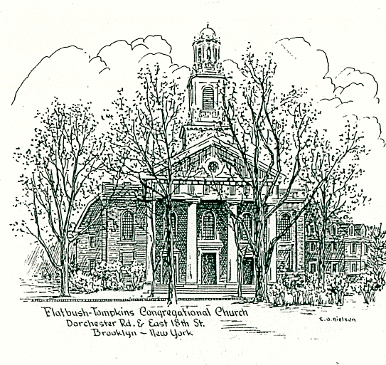

424 East Nineteenth Street, Brooklyn, New York 11226

Tel. 718-282-5353 / Fax 718-940-0988

**Reverend Doreen Forde**

Interim Minister

The mission of this church is to provide a place to worship and learn the

will of God; to share in Christian fellowship showing encouragement and

love to each other, gaining spiritual strength for our personal needs

and, as disciples of Christ, to communicate our love to all people

by deeds and actions.

____________________________________________________________________

***Sunday July 21, 2024***

***at 11:00 a.m. in the morning***

*_________________________________________________________________________________________________________________________________________________*

*Member*

NATIONAL ASSOCIATION of CONGREGATIONAL CHRISTIAN CHURCHES

**FLATBUSH-TOMPKINS CONGREGATIONAL CHURCH**

Rev. Doreen Forde Interim *Minister*

*Liturgist; Janice Thomas*

**Sunday, July 21, 2024 at 11:00 a.m.**

**Prelude** Rachel Kaufman *Emma Lou Diemer*

**\*Opening Hymn # 343 I Am Thine, O Lord**

**\*Call to Worship**

When we think of God’s presence in the world,

We are grateful:

***Grateful for the presence of hope;***

***grateful for the gift of life.***

And when we think of God’s presence in our lives,

we are humbled:

***Humbled by the gift of grace;***

***humbled by the invitation to begin again.***

And when we think of God’s presence in this community,

we are glad:

**Glad to be surrounded by holy people worshiping our Holy God**. Thank you all; thank you God. ***. Amen***

**\*Introit** Welcome Into This Place

**\*Invocation and Lord’s Prayer** (debts……debtors)

**\*Responsive Reading**

**\* Psalter 716** - Psalm 133

**\*Gloria Patri**

**Welcome and Announcements**

**Pastoral Prayer**

**Prayer Response #403** **Lord Listen To Your Children Praying**

**Elisabeth Stevens**

**Offering**

**Anthem**  ***Selection***

***Elisabeth Stevens***

**\*Doxology**

**\*Prayer of Dedication**

**Scripture Reading**

**Old Testament Lesson** (pew Bible p.541) Psalms100: 1-5

**\*Hymn of Preparation #49** God Is So Good

**Sermon “God Is So Good”**

**Invitation to Christ**

**Hymns of Invitation #418 Take Time to Be Holy**

**\*Closing Hymn 281 Count Your Blessings TBA**

**\*Benediction**

**\* Choral Response #579** Lord Dismiss Us With Thy Blessing

**Postlude** Rachel Kaufman Sevil Macmot

Sevil Macmot

\**congregation standing*

*(Please remain seated until after the Postlude is finished.***)**

**Music Ministry**

Rachel Kaufman - Guest Organist/Choir Director

Elisabeth Stevens Soprano

The ushers and greeters are members of the Standing Committee.

**Church Notes**

We welcome you to our service of worship this morning. We are so pleased

that you have come to fellowship with us today. We encourage you to greet

each other and join us for fellowship after service.

*“Study to show thyself approved unto God, a workman that needeth not*

*to be ashamed, rightly dividing the word of truth.”* 2 Timothy 2: 15 KJV

Please pray for those on our Prayer list.

**Happy Birthday** to our July birthday celebrants!

***Save the Date***

July 27 - Jumble Sale, Noon to 3:00pm

August 10 - Backpack Distribution

**A Message from Rev. Forde**

**Surely God must be pleased with your overwhelming response to the call to reactivate the church’s prayer ministry. If you would like to be a part of this vital ministry, we will have a preliminary meeting after church on Sunday, August 11, 2024. Please come with your thoughts, ideas, and vision. Please reach out to Rev. Forde with any questions.**